Wood Badge Ticket:
A Personal Statement of Vision and Mission

Final Write-Up
Course: | S5-420-13Course Number Goes Here
Name: | John GreenYour Name Goes Here
Patrol: | FoxYour Patrol Critter Goes Here
Date: | Submission Date
Summary of My Wood Badge Experience:
In this section, summarize your entire Wood Badge experience. This is a chance for you to tell your story. Some suggested topics to include would be:

what led you take to take Wood Badge

what challenges did you have to overcome

your patrol experience

the contacts you made on the course

what you learned about Scouting that was new to you

why you chose a particular ticket item

identify who you did this for
Ticket Item One:
Title for Ticket Item One
Item Evidence of Completion
- List all the ways the completion of this ticket item can be verified
- Photographs and other documentation can be added to the Appendix and referenced below.

See Appendix A1 for copies of item evidence referenced within this section.
Reflection
Tell the story of this ticket item. Make it personal, don’t just give facts
Show what this ticket item meant to you before you did it and tell about any new meaning that was gathered from it on completion.
Tell of any changes to yourself, your unit, or district as a result of this ticket item.

Ticket Item Two: FULL EXAMPLE
Lead a group of Scouts in the Pioneering Merit Badge
Objective Evidence of Completion
- Spent 9 months learning the knots and lashings myself to be able to lead the Pioneering Merit Badge.
- When I was ready, I took Merit Badge Counselor Orientation, applied and was accepted to be a Merit Badge Counselor for the badge on a Council level.
- Spent three months working with a group of Scouts on the badge before, during, and often after troop meetings as well as some weekends.
- Led the badge with a motto of Nature Not Lecture. Meaning that in the course of outings and activities, Scouts build skills while having fun.
- Used several Pioneering based games and devised a few of my own that had the scouts meeting the requirements in order to learn and play the games.
- Photographs of Scouts participating are in Appendix B4.

See Appendix B2 for copies of item evidence referenced within this section.
Reflection
This was by far my hardest, most time intensive ticket item. I decided to take on Pioneering because I was terrible at knots and knew nothing of lashings. I knew my skills were poor and needed much improvement. I spent 9 months practicing knots and lashings everywhere I went. I carried paracord, ropes, and small dowel rods with me at all times and practiced whenever I had a spare moment. It did raise a few eyebrows in airports, but it helped pass the time and really built up my skills.
After leading them through various games and projects for three months, I have 9 Scouts that have completed all the requirements for the badge.
As with every other ticket item I've done, this one continues to have a life of its own. Beyond increasing my own skills, the Troop PLC decided to do Pioneering presentations at our District Scout Show this Spring. Specifically running the Round Lashing Game I devised for the Badge work and the rope making machine that I built to show the public and other Scouts how fun Pioneering can be.
They also decided to build a Catapult for Summer Camp this year. I supervised a few of them one weekend on cutting and curing some Bamboo spars to build a a catapult for camp. We'll be getting the Troop together a couple of times before week one to lash it together and do some test launches.
The boys decided on their own to do these Pioneering projects, going above and beyond the badge work I led them through. They did it because they found it fun. That fact makes this both the hardest and most successful ticket item for me.
Ticket Item Three:
Title for Ticket Item Three
Item Evidence of Completion
- List all the ways the completion of this ticket item can be verified
- Photographs and other documentation can be added to the Appendix and referenced below.

See Appendix C1 for copies of item evidence referenced within this section.
Reflection
Tell the story of this ticket item. Make it personal, don’t just give facts
Show what this ticket item meant to you before you did it and tell about any new meaning that was gathered from it on completion.
Tell of any changes to yourself, your unit, or district as a result of this ticket item.
Ticket Item Four:
Title for Ticket Item One
Item Evidence of Completion
- List all the ways the completion of this ticket item can be verified
- Photographs and other documentation can be added to the Appendix and referenced below.

See Appendix D1 for copies of item evidence referenced within this section.
Reflection
Tell the story of this ticket item. Make it personal, don’t just give facts
Show what this ticket item meant to you before you did it and tell about any new meaning that was gathered from it on completion.
Tell of any changes to yourself, your unit, or district as a result of this ticket item.
Ticket Item Five:
Title for Ticket Item One
Item Evidence of Completion
- List all the ways the completion of this ticket item can be verified
- Photographs and other documentation can be added to the Appendix and referenced below.

See Appendix E1 for copies of item evidence referenced within this section.
Reflection
Tell the story of this ticket item. Make it personal, don’t just give facts
Show what this ticket item meant to you before you did it and tell about any new meaning that was gathered from it on completion.
Tell of any changes to yourself, your unit, or district as a result of this ticket item.
Appendix A – Approved Ticket Worksheets

The first part of the Appendix should be the scans of your original ticket worksheets.
Appendix A – Approved Ticket Worksheets 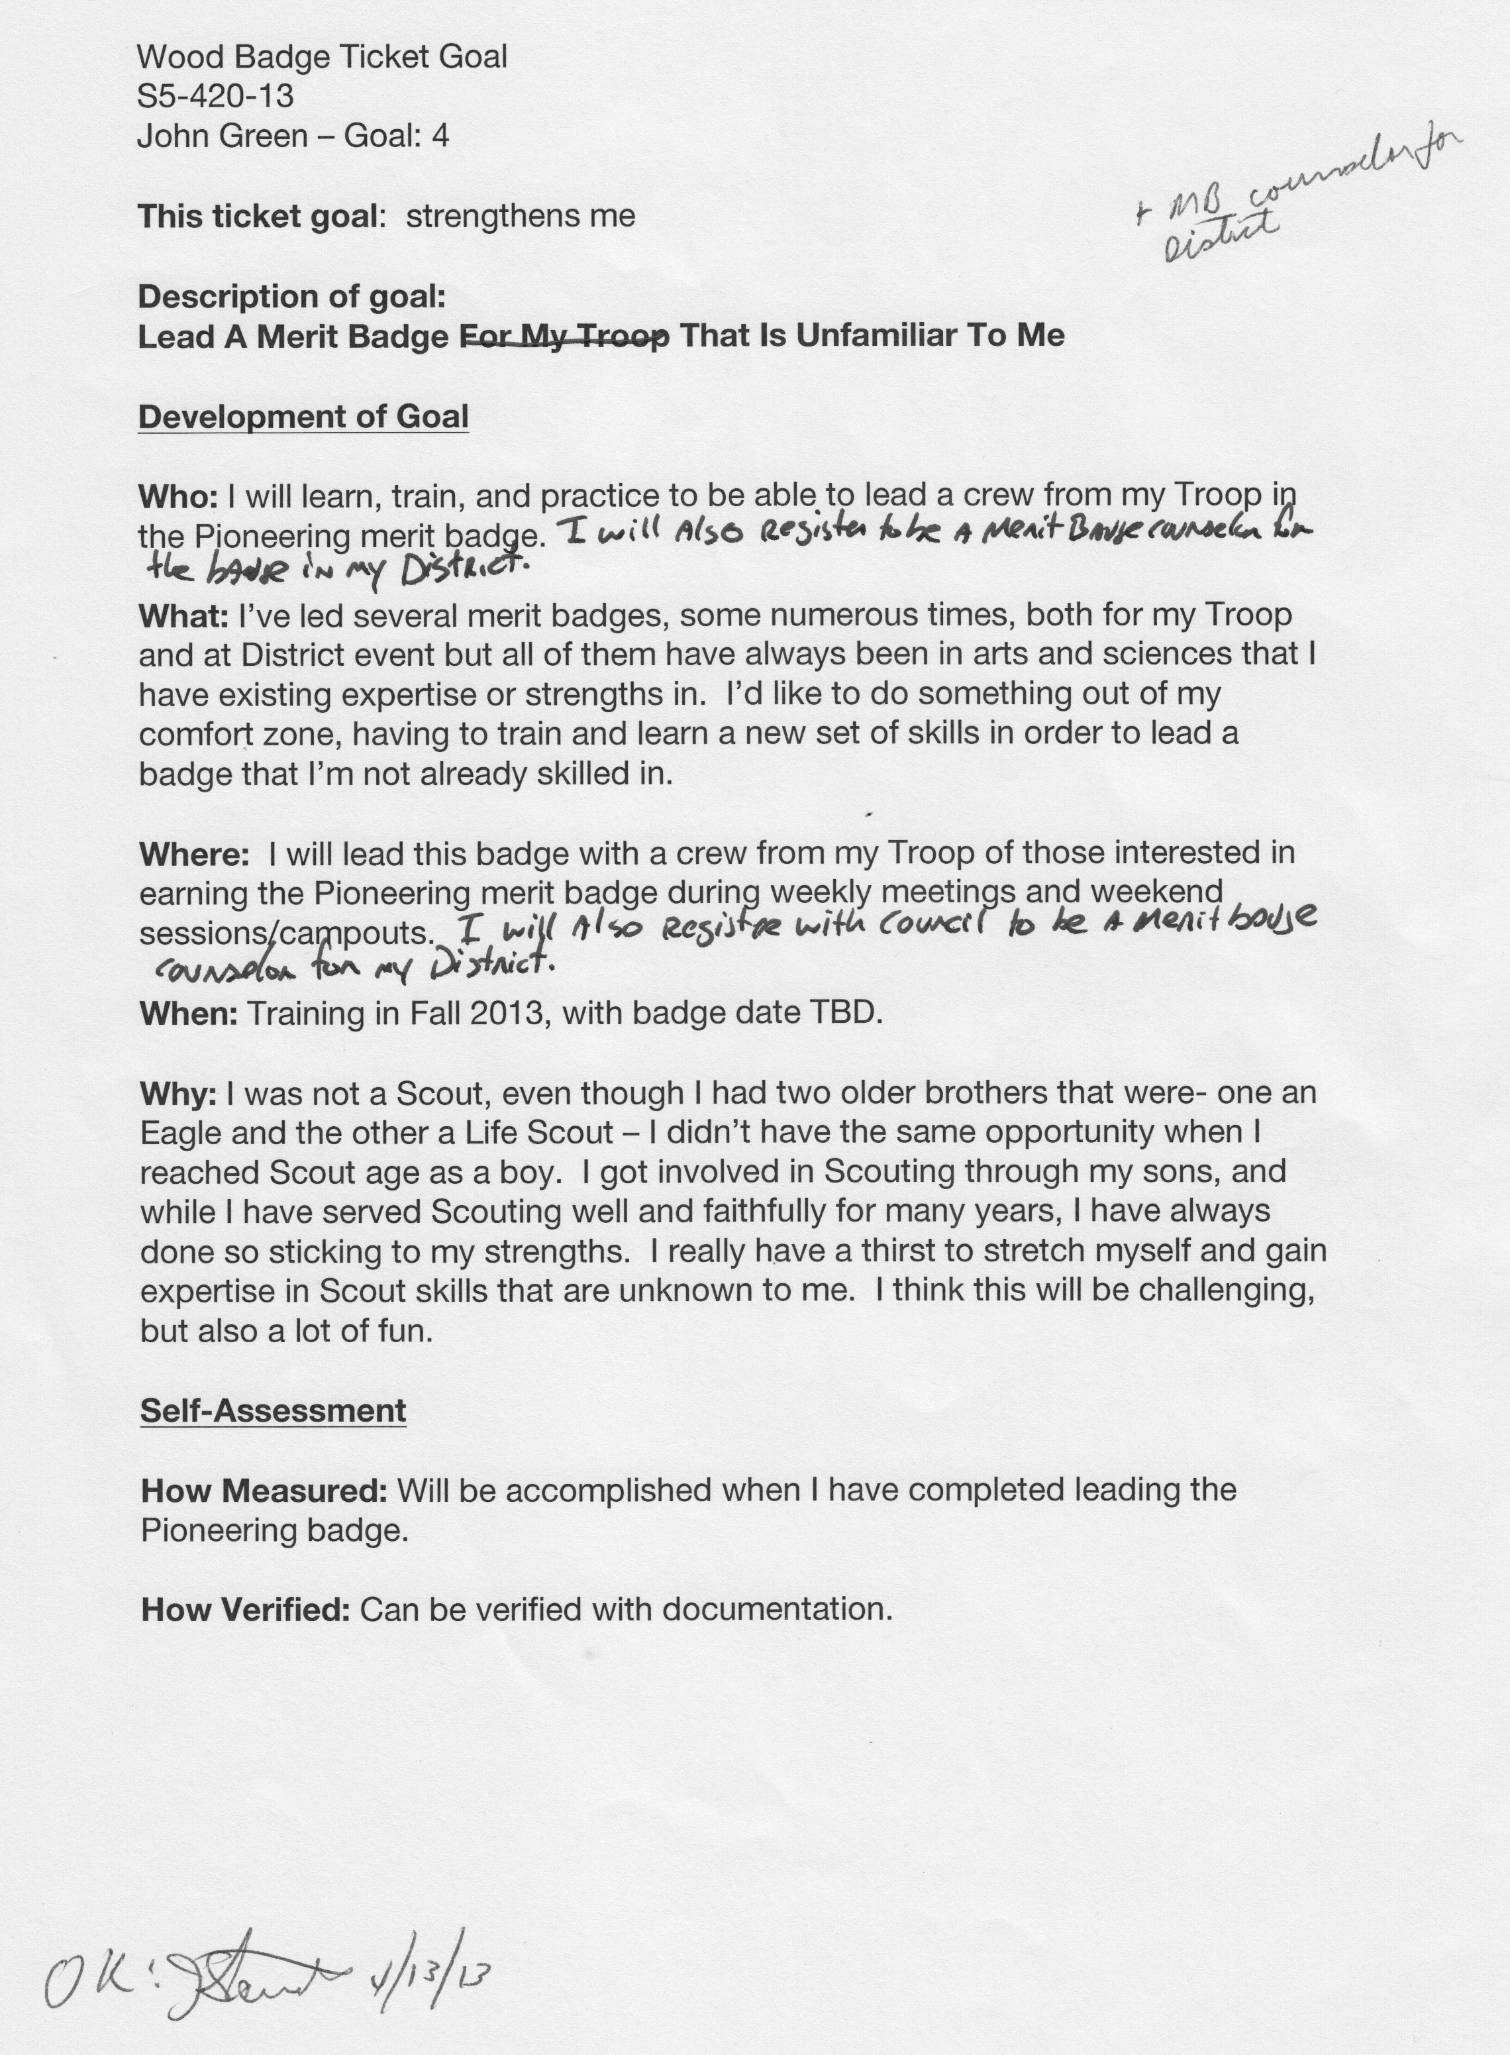

The first part of the Appendix should be the scans of your original ticket worksheets.
Appendix A – Approved Ticket Worksheets

The first part of the Appendix should be the scans of your original ticket worksheets.
Appendix A – Approved Ticket Worksheets

The first part of the Appendix should be the scans of your original ticket worksheets.

Appendix A – Approved Ticket Worksheets

Include the scans of any items you had approved but did not use for your ticket.

Appendix B2 – Item Two Evidence of Completion
Video: https://www.youtube.com/watch?v=qQgQ7AcANK0

